Microbiology · Exam 1 — Study Guide
Editable Word copy of the PA_Quizzes study aid. Headings use real Word styles, so the navigation pane and the contents field below both work, and restyling one heading restyles them all.
[In Word: right-click here and choose Update Field to build the contents.]

1 · Review of General Microbiology
INSTRUCTIONAL OBJECTIVES
- Describe an overview of molecular mechanisms related to microbiology that influence health and disease
- Describe the types of infectious pathogens.
- Compare and contrast standard and specialized structures of a bacterial cell.
- Describe bacterial cell morphologies, including Gram-staining characteristics.
- Review the methods utilized in bacterial identification.
- Review the types of culture media used to identify pathogens.
- Review the phases of the bacterial growth curve.
- Differentiate the different processes of phage replication.
- Compare and contrast phage replication to animal virus replication.
- Describe the cytopathic effects of viruses.
- Describe the health implications of nucleic acid mutations.
- Describe the basic mechanisms of microbial control.
- Review the bacterial death curve.

NOTE
Thirteen objectives — about double a normal lecture. This one spans bacteriology, virology, mycology, parasitology, genetics and control. The sections below run in objective order, so you can revise one at a time rather than by slide number.

1.1 · Objective 1 — Molecular mechanisms influencing health and disease
Mechanism | How it works | Worked example
Receptor binding | Specific interaction between a pathogen surface protein and a host cell receptor | Influenza uses hemagglutinin to bind sialic acid receptors
Adhesion | Initial attachment via proteins, carbohydrates or lipids to specific host receptors | Escherichia coli uses type I fimbriae on mannose receptors, colonising the urinary tract
Invasion | Entry into host cells | Salmonella enterica injects effector proteins via a secretion system to build a replication niche
Virulence factors | Pathogen molecules enhancing the ability to cause disease — toxins, adhesins, invasins | Staphylococcus aureus adhesins, plus Panton-Valentine leucocidin, which lyses neutrophils, monocytes and macrophages
Molecular signalling | Host pattern recognition receptors read pathogen associated molecular patterns | Triggers immune cell activation, cytokine production and regulation of inflammation

Environmental factors also shape transmission: temperature and humidity (influenza is more stable and transmissible at low temperature and high humidity), where vectors can flourish, and human behaviour — hygiene, vaccination rates and travel patterns.

1.2 · Objective 2 — Types of infectious pathogens
 | Prokaryotic | Eukaryotic
Cells | Simple, few organelles, no defined nuclear membrane | Complex, many organelles, genetic material within a nuclear membrane
Chromosome | Circular, “naked” DNA | Linear, DNA with histone proteins
Cell wall | Peptidoglycan | Carbohydrate based
Ribosomes | 70S | 80S
Members | Bacteria | Fungi, protozoa, helminths

Viruses sit outside both, as noncellular infectious agents.
Atypical bacteria | Defining feature | Examples
Chlamydias | Tiny obligate intracellular; not arthropod-transmitted | Chlamydia trachomatis, Chlamydia psittaci
Rickettsias | Tiny obligate intracellular; transmitted by fleas, ticks, lice | Rickettsia rickettsii, Rickettsia prowazekii, Coxiella burnetii
Mycoplasmas | Tiny, pleomorphic, lack a cell wall | Mycoplasma pneumoniae

Eukaryotic microbe | Key divisions
Fungi (100,000 species) | Macroscopic (mushrooms, puffballs) and microscopic — yeasts unicellular (Candida albicans), molds multicellular and filamentous (Penicillium notatum). Differentiated by spore type
Protozoa (65,000 species) | Mostly unicellular; differentiated by motility. Two forms: trophozoite (motile feeding) and cyst (dormant resistant). Groups: Mastigophora (flagellates — Trypanosoma), Sarcodina (amoebas — Entamoeba), Ciliophora (ciliates — Balantidium), Apicomplexa (essentially nonmotile — Plasmodium)
Helminths | Flatworms — no definite body cavity, digestive tract a blind pouch; cestodes (tapeworms), trematodes (flukes). Roundworms (nematodes) — complete digestive tract, protective cuticle, spines and hooks

Other noncellular agents. Prions are misfolded proteins with no nucleic acid, causing spongiform encephalopathies — scrapie, bovine spongiform encephalopathy, and Creutzfeldt-Jakob Disease in humans. Viroids are short pieces of ribonucleic acid with no protein coat, so far identified only in plants. The two are opposites: protein without nucleic acid, and nucleic acid without protein.

1.3 · Objective 3 — Standard and specialized bacterial structures
Structure | Type | Function
Flagellum | Specialized | True directional motility
Pilus | Specialized | Coded by a plasmid; used in bacterial conjugation
Fimbriae | Specialized | Adhesion to membrane surfaces
Glycocalyx | Special | Capsule or slime layer — biofilm production, prevents desiccation, prevents phagocytosis (a factor of pathogenicity; Streptococcus pneumoniae)
Plasmids | Internal | Small circular double-stranded DNA, free or integrated, not essential to growth. May encode antibiotic resistance, tolerance to toxic metals, enzymes and toxins
Endospores | Internal | Survival mechanism — genetic material in a resistant coat, very low metabolism. Genera: Bacillus, Clostridium
Inclusions | Internal | Storage or waste — phosphate, oil droplets

1.4 · Objective 4 — Morphology and Gram staining
Three shapes, and the lecture is explicit that shape matters for identification: cocci (spherical), bacilli (rod), and spiral (helical, comma, twisted rod, spirochete).
Peptidoglycan is a polymer of alternating N-acetyl glucosamine and N-acetyl muramic acid, crosslinked by a short peptide bridge between the terminal D-alanine and the penultimate diamino-containing amino acid. Crosslinking is catalyzed by transpeptidases — the target of beta lactam antibiotics. The link can be direct, or indirect through a pentaglycine spacer as in Staphylococcus aureus.
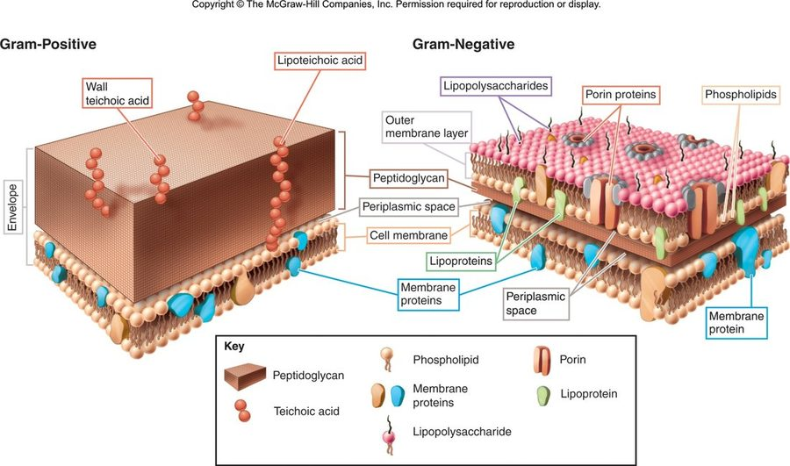
The figure that makes the whole Gram stain make sense. On the left, one thick slab of peptidoglycan with teichoic and lipoteichoic acid threaded through it — that bulk is what traps crystal violet, and why the cell stains purple. On the right, a thin peptidoglycan shell sitting under an outer membrane studded with lipopolysaccharide and porins, with a periplasmic space between. The thin layer cannot hold the dye through decolorization, so the cell takes up safranin instead. Everything else follows from this picture: Lipid A sits in that outer membrane, which is why only Gram-negatives carry endotoxin, and the outer membrane is the barrier that makes them chemically resistant. Copyright © The McGraw-Hill Companies. Reproduced from the lecture slides (Slide 35).
Gram stain step | Reagent | Time
1 | Crystal violet | 1 min
2 | Gram's iodine | 1 min
3 | Acetone alcohol (decolorize) | ~10 sec — the most critical step, and the one most affected by technical variation in timing and reagents
4 | Safranin | 1 min

 | Gram positive | Gram negative
Wall | Thick homogenous peptidoglycan, 20–80 nm, with teichoic and lipoteichoic acid and surface proteins | Outer membrane (asymmetric bilayer, outermost layer lipopolysaccharide), periplasmic space, thin peptidoglycan shell, inner cytoplasmic membrane
Stain | Retains crystal violet → purple | Loses crystal violet → red from safranin counterstain
Strength | Physically strong — resists temperature, pH, osmotic pressure | Chemically strong — resists disinfectants, antibiotics

Lipopolysaccharide has three parts, and each is examinable separately: Lipid A (endotoxin activity), core polysaccharide, and O-polysaccharide (used in bacterial classification).

1.5 · Objectives 5 & 6 — Identification methods and culture media
Methods of bacterial identification: microscopic morphology · macroscopic morphology (colony appearance) · physiological and biochemical characteristics · chemical analysis · serological analysis · genetic and molecular analysis (guanine plus cytosine base composition, deoxyribonucleic acid analysis with genetic probes, nucleic acid sequencing and ribosomal ribonucleic acid analysis).
Requirements for growth divide into chemical — water, energy nutrients (carbohydrates, proteins, lipids), vitamins, minerals, oxygen levels — and physical — temperature, pH, osmotic pressure.
Media type | Definition
Synthetic (chemically defined) | Pure organic and inorganic compounds in an exact chemical formula
Complex / nonsynthetic | At least one ingredient that is not chemically definable
General purpose | Grows a broad range of microbes; usually nonsynthetic
Enriched | Complex organic substances — blood, serum, haemoglobin, or special growth factors for fastidious microbes
Selective | Contains agents that inhibit some microbes and encourage the desired ones
Differential | Allows several types to grow and displays visible differences between them

The categories combine: blood agar is enriched and differential (gamma, beta and alpha haemolysis); mannitol salt agar is selective and differential.

1.6 · Objective 7 — The bacterial growth curve
Growth means an increase in number, not size, by binary fission — which is why it is exponential rather than arithmetic.
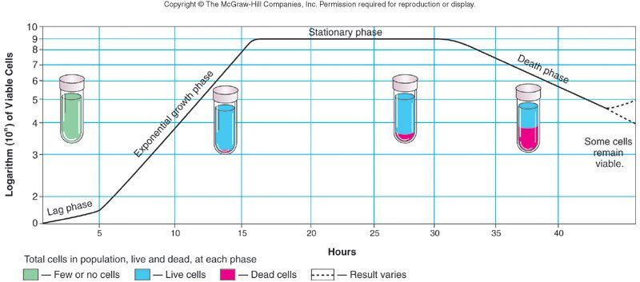
Note the vertical axis is a logarithm of viable cells — which is why exponential growth appears as a straight line rather than a curve. The tubes underneath are the part worth studying: they show the population composition at each phase, so the stationary plateau is visibly not a pause but a balance, with cells dividing and dying at the same rate. The dashed tail is worth noticing too, since some cells remain viable after the death phase — which is exactly why sterilisation is defined by probability rather than by a moment when the last organism dies. Copyright © The McGraw-Hill Companies. Reproduced from the lecture slides (Slide 49).
Phase | What is happening
Lag | Flat period of adjustment and enlargement; little growth
Exponential growth | Maximum growth, continuing as long as nutrients and environment allow. Most vulnerable to control methods here — the lecture's example is penicillin
Stationary | Rate of growth equals rate of death, from depleted nutrients and oxygen and excretion of organic acids and pollutants
Death | Limiting factors intensify; cells die exponentially in their own wastes

1.7 · Objectives 8 & 9 — Phage and animal virus replication
All viruses have capsids — protein coats enclosing and protecting the nucleic acid — which may be helical, icosahedral or complex. They contain either deoxyribonucleic acid or ribonucleic acid, and may have an envelope or spikes.
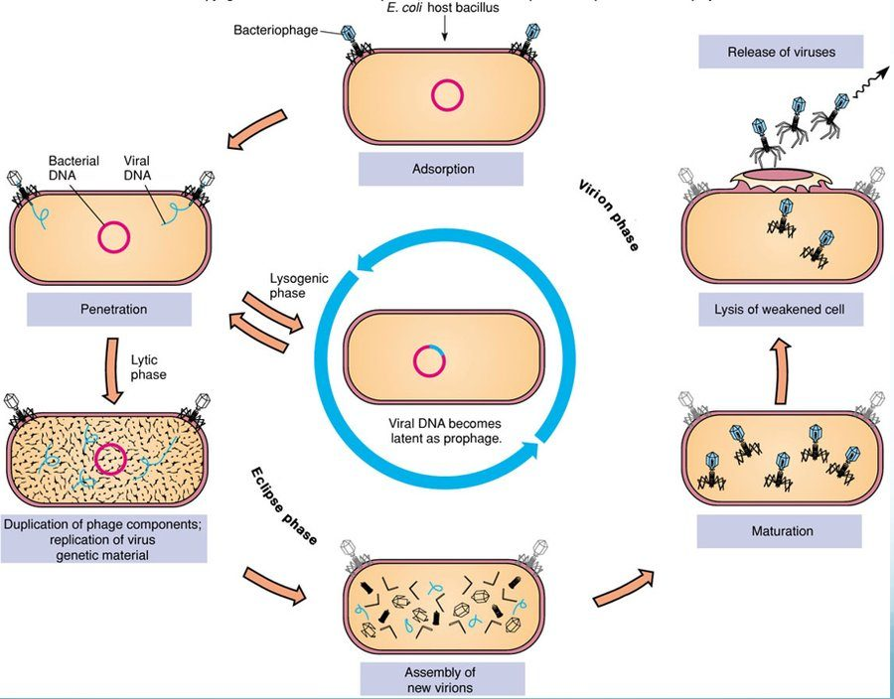
Both cycles on one diagram, which is the clearest way to see that they share a beginning and diverge afterwards. Adsorption and penetration happen either way. The outer ring is the lytic route — duplication, assembly, maturation, then lysis of the weakened cell. The blue loop through the centre is lysogeny: the viral genome goes latent as a prophage and is copied along with the host, which is how a bacterium can inherit a phage-encoded toxin gene without ever appearing infected. Reproduced from the lecture slides (Slide 56).
Step | What happens
1 Adsorption | Binding of virus to a specific molecule on the host cell
2 Penetration | Genome enters the host cell
3 Replication | Viral components produced
4 Assembly | Viral components assembled
5 Maturation | Completion of viral formation
6 Release | Viruses leave the cell to infect others

Lytic cycle | Lysogenic cycle
Rapid takeover of bacterial metabolism  Multiple virus copies produced  Destruction of the host cell  Generalized transduction — random pieces of host DNA may be transmitted to other bacteria | Integration of viral genes as prophage  May acquire new traits — e.g. the ability to make a toxin  Immune to reinfection  Viral genes replicated with the host cell  Specialized transduction — all cells carry the same host DNA

NOTE
Animal viruses differ from phages in three ways. The entire virion is engulfed; uncoating is required to release the genetic material (driven by the difference between cytoplasmic and extracellular pH); and release is by budding, which may assist acquisition of an envelope. A phage injects its genome through the wall, so it needs no uncoating.

1.8 · Objective 10 — Cytopathic effects of viruses
Virus-induced damage to cells: changes in size and shape · cytoplasmic inclusion bodies · nuclear inclusion bodies · cells fusing to form multinucleated cells · cell lysis · alteration of deoxyribonucleic acid, which may activate oncogenes · transformation of cells into cancerous cells.
Radiation and chemical exposure can activate oncogenes by the same route, which is why this slide links infection to malignant transformation rather than treating them separately.

1.9 · Objective 11 — Health implications of nucleic acid mutations
A mutation is a change in the base sequence of the genome which may impact the phenotype. Mutations occur naturally at a low level but may be induced by radiation, chemicals or viruses, and may be beneficial, neutral or deleterious.
Route | Mechanism
Transformation | Taking up naked DNA from the environment
Conjugation | Cell to cell transmission of DNA from a plasmid
Transduction | Transmission of genetic material by viral vector

Where the mutation is | Health implication
Bacteria | New traits — resistance to antibiotics or other control methods, ability to produce toxins or other virulence factors
Viruses | High mutation rates change surface antigens and transmission factors. Changing surface properties may weaken or eliminate immunity from vaccination or prior exposure; previously host-specific animal viruses can cross to humans, where immunity is unlikely to exist
Human hosts | Chemical or radiation exposure may transform normal cells to cancer cells; oncogenic viruses may do the same; viruses may affect immune cells (human immunodeficiency virus with acquired immunodeficiency syndrome, autoimmune disorders)

1.10 · Objectives 12 & 13 — Microbial control and the death curve
Aseptic or sterile means removal of all forms of microbial contamination; disinfection means elimination of some. Depending on circumstances, lowering numbers rather than total elimination may be good enough.
Two basic mechanisms: alteration of membrane permeability, and denaturation of proteins and nucleic acids.
Physical control | Detail
Temperature | High can kill; low will NOT — it only slows growth. Dry heat (ovens); wet heat (boiling, autoclave, pasteurization); refrigeration and freezing for preservation
pH | Most pathogens prefer neutral, so acid or base inhibits — pickling
Osmotic pressure | Increase sugar or salt concentration
Filtration | For heat-sensitive solutions — vaccines, sera, beer
Radiation | Ionizing (X-ray, gamma) and non-ionizing (ultraviolet)

Chemical control | Detail
Disinfectants | Used on inanimate objects — Lysol
Antiseptics | Used on tissues — Listerine mouthwash
True chemical sterilants | Very few. Ethylene oxide (plastics, spices); beta propiolactone (vaccines, tissue grafts, surgical instruments)
Adequate for purpose | Halogens such as chlorine or bromine; alcohol

Antimicrobial chemotherapeutic agents should have selective toxicity — working against the microbial agent without harming the host. Synthetic agents include the sulfa drugs, made from coal tar dyes; antibiotics are substances naturally made by one microorganism against another, such as penicillin from the Penicillium mold, active against Gram-positive bacteria.
The bacterial death curve. Under a control method the rate of death is constant. Decimal reduction time is the time taken to kill 90% of the organisms. So from roughly 4.9 million organisms with a decimal reduction time of 10 minutes, each interval leaves a tenth: ~486,000 → ~48,600 → ~4,860. The count never formally reaches zero, which is why sterilisation is defined by probability rather than by a moment when the last organism dies.
Source: Lecture 1 — Review of General Microbiology (Dr. Webster), Slides 1–70, and the PAJ 5200 syllabus instructional objectives.

2 · Antibiotics and Resistance
INSTRUCTIONAL OBJECTIVES
- Describe major historical events in microbial control.
- Describe criteria for drug selection for prokaryotes and eukaryotes.
- Define therapeutic index including calculations and significance.
- Discuss the effect of drug clearance on dosing schedule.
- Compare and contrast antibiotics and the organisms of major antibiotic drug lines.
- Compare and contrast the basic mechanisms of action of antimicrobial agents and give examples of each.
- Describe mechanisms of drug resistance.
- Describe other potential problems with antimicrobial therapy.

2.1 · Objective 1 — Major historical events in microbial control
When | Who / what
350–550 AD | Tetracycline traces in Sudanese Nubian skeletal remains — from beer made with fermented grain containing Streptomyces
1600s | Cinchona bark used for malaria and febrile conditions (quinine)
1870 | Burdon-Sanderson: culture fluid covered with mould did not grow bacteria
1877 | Pasteur: anthrax bacilli inhibited by mould growth
1897 | Duchesne healed typhoid-infected guinea pigs with Penicillium
1909 | Ehrlich — drugs as “magic bullets”; developed arsphenamine (salvarsan) against Treponema pallidum
1928 | Fleming — inhibition of Staphylococcus on plates contaminated with Penicillium
1935 | Domagk — sulfonamides from coal tar dyes
1939 | Florey and Chain — produced a stable clinical form of penicillin
1943 | Waksman — Streptomyces produce antibiotics; coined the term, discovered over twenty
1945 | Fleming, Florey and Chain share the Nobel prize in medicine (Waksman's follows in 1952)

Ehrlich's “magic bullet” is the same idea later formalised as selective toxicity, and the string of pre-Fleming observations — Burdon-Sanderson, Pasteur, Duchesne, Gosio — is worth noticing: the phenomenon was seen repeatedly for decades before anyone made a drug from it.

2.2 · Objective 2 — Criteria for drug selection
Term | Definition
Chemotherapy | The use of drugs to treat a disease
Antimicrobial drug | Interferes with the growth of microbes within a host
Antibiotic | A substance produced by a microbe that, in small amounts, inhibits another microbe
Selective toxicity | Kills harmful microbes without damaging the host — achieved by targeting processes or structures the pathogen has and the host does not

 | Bactericidal | Bacteriostatic
Effect | Kills organisms directly | Inhibits growth
Measure | Minimal bactericidal concentration — the minimum level killing 99.9% of test organisms | Minimal inhibitory concentration — the minimum level inhibiting growth

What makes a good agent — there is no perfect drug, but the lecture lists: selective toxicity · favourable pharmacokinetics (reaching the target site at an effective concentration) · appropriate spectrum of activity (broad = large range of organisms, narrow = small) · lack of side effects · low direct toxicity · low potential for hypersensitivity · good therapeutic index · little resistance development.
NOTE
Why eukaryotic pathogens are harder. There are not as many drugs in the pharmacopeia, and treatment is more difficult because cell structure and some physiology resemble the human host's — so there is a great possibility of toxic side effects. Selective toxicity is the whole problem.

Choosing the agent in practice: the disk-diffusion (Kirby Bauer) method reads a zone of inhibition against a chart correcting for concentration, molecular weight and other diffusion factors. The E test (“minimal inhibitory concentration on a stick”) reads that value directly in micrograms per millilitre, where the zone of inhibition meets the strip.

2.3 · Objectives 3 & 4 — Therapeutic index and drug clearance
Therapeutic window | The range of plasma concentrations spanning the minimum concentration for clinical efficacy and toxicity
Therapeutic index | A calculation assessing the safety and efficacy of a drug:  TI = maximum tolerated dose ÷ minimum inhibitory concentration  = TD50 (median toxic dose) ÷ ED50 (median effective dose)
Drug clearance | Renal clearance + hepatic clearance + clearance from all other tissues

A higher therapeutic index means a wider margin between the dose that works and the dose that harms — the safer drug. And clearance drives the dosing schedule for one reason: you must not let the concentration fall below the minimal inhibitory concentration, remembering that it takes time for the drug to enter the system in the first place.

2.4 · Objective 5 — Drug lines and their producing organisms
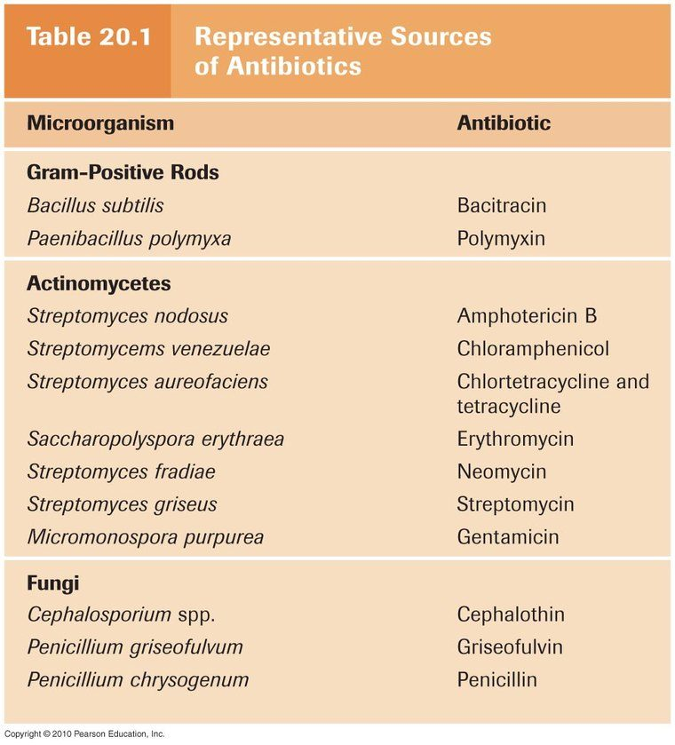
Objective 5 asks for the antibiotics and the organisms of the major drug lines, and this is that objective in one table. Note the grouping, which is the part worth learning rather than the individual rows: the actinomycetes — overwhelmingly Streptomyces — give the protein synthesis inhibitors, the fungi give the beta-lactams and griseofulvin, and only two agents come from Gram-positive rods . The exceptions are what get tested: gentamicin comes from Micromonospora , not a Streptomyces , and erythromycin from Saccharopolyspora . Table 20.1, copyright © 2010 Pearson Education. Reproduced from the lecture slides (Slide 11).
Drug | Produced by
Penicillin | Penicillium chrysogenum (now P. notatum)
Cephalosporins | Cephalosporium acremonium
Bacitracin | Bacillus subtilis
Vancomycin | Amycolatopsis orientalis (formerly Nocardia orientalis)
Chloramphenicol | Streptomyces venezuelae
Streptomycin | Streptomyces griseus
Neomycin | Streptomyces fradiae
Gentamycin | Micromonospora purpurea — not a Streptomyces
Tetracyclines | Streptomyces aurofaciens
Erythromycin | Saccharopolyspora erythraea
Polymyxin B | Paenibacillus polymyxa
Rifamycin | Amycolatopsis rifamycinica
Amphotericin B | Streptomyces nodosus
Nystatin | Streptomyces noursei
Quinolones, sulfonamides | Artificially produced — sulfonamides from coal tar dyes

2.5 · Objective 6 — Mechanisms of action
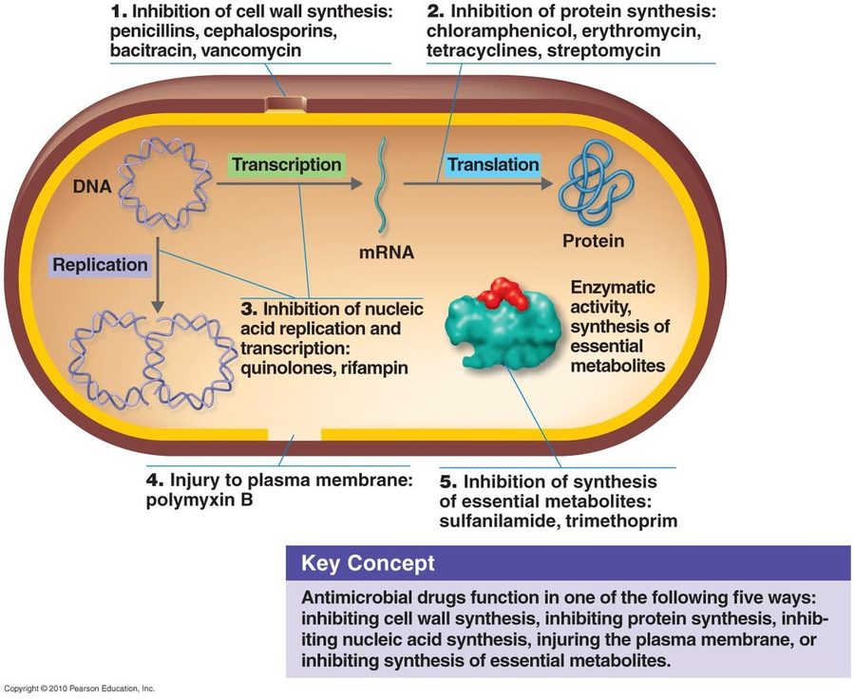
Every mechanism in this lecture reduces to one of five targets, and this diagram places each on the cell with its example drugs attached. Read it as a map of where selective toxicity comes from: the cell wall and the 70S ribosome are structures the human host does not share, which is why those two categories hold most of the antibacterials. The metabolite pathway is the subtlest — sulfonamides work because bacteria must synthesise folate while humans absorb it. Copyright © 2010 Pearson Education. Reproduced from the lecture slides (Slide 17).
Target | Agent | Precise mechanism
Cell wall synthesis | Penicillins | Bind penicillin-binding proteins; inhibit transpeptidase (blocking cross links); produce autolysins (breakdown without synthesis)
Cephalosporins | Similar to penicillin's transpeptidase action. 1st gen narrow/Gram-positive → 2nd extended to Gram-negative → 3rd includes pseudomonads, injected → 4th oral
Bacitracin | Interferes with bactoprenol, the transporter carrying peptidoglycan monomers across the membrane, preventing dephosphorylation → osmotic lysis. Topical only, too toxic parenterally
Vancomycin | Glycopeptide binding NAG/NAM subunits, preventing incorporation. “Last line” against resistant Staphylococcus aureus
Isoniazid / ethambutol | Mycobacteria have different walls: isoniazid inhibits mycolic acid synthesis, ethambutol its incorporation
Protein synthesis | Chloramphenicol | Binds 50S; inhibits peptide bond formation. Broad spectrum
Aminoglycosides | Change the shape of the 30S subunit → inaccurate reading of messenger RNA codons. Broad spectrum
Tetracyclines | Interfere with transfer RNA attachment. Broad spectrum
Streptogramins | Two components acting together on the 50S subunit. Gram-positives
Erythromycin | Binds 50S; prevents amino acid translocation from transfer RNA to the ribosomal binding site. Gram-positives
Plasma membrane | Polymyxin B | Disrupts the outer membrane of Gram-negatives and the inner membrane by attaching to lipid components. Topical, with bacitracin and neomycin over the counter
Nucleic acid synthesis | Rifamycin | Inhibits RNA polymerase. Antituberculosis
Quinolones / fluoroquinolones | Inhibit DNA gyrase, preventing unwinding. Urinary tract and hospital acquired infections
Essential metabolites | Sulfonamides | Competitive inhibitors — resemble para-aminobenzoic acid, inhibiting folic acid synthesis. Broad spectrum

Antifungal class | Mechanism
Polyenes (amphotericin B, nystatin) | High affinity for ergosterol in fungal membranes → pore formation, ergosterol sequestration, reactive oxygen species
Echinocandins | Block synthesis of beta-glucan, an essential cell wall component. Intravenous; Candida and Pneumocystis
Azoles | Inhibit ergosterol synthesis — membrane
Allylamines | For azole-resistant infections
Griseofulvin | Inhibits microtubule formation during cell division. Superficial dermatophytes
Tolnaftate | Inhibits squalene epoxidase → blocks ergosterol synthesis; distorts hyphae
Flucytosine | Cytosine analog — interferes with RNA synthesis and causes miscoding

Polyenes versus azoles is the classic pairing. Both concern ergosterol, but polyenes bind ergosterol that is already in the membrane, while azoles block its synthesis. Echinocandins are the odd one out — they act on the cell wall, not the membrane at all.
Antiviral strategy | Example / detail
Nucleoside and nucleotide analogs | Remdesivir binds viral RNA-dependent RNA polymerase and terminates transcription prematurely. Broad activity against Ebola, respiratory syncytial virus and coronaviruses
Protease inhibitors | Block cleavage of viral polypeptide precursors into mature enzymes and structural proteins. Human immunodeficiency virus — indinavir, amprenavir
Integrase inhibitors | Prevent viral DNA entering the host chromosome, so it is ultimately degraded
Attachment / fusion | Block CCR5 — human immunodeficiency virus
Neuraminidase inhibitors | Prevent the virus escaping the host to infect others — influenza
Uncoating inhibitors | Amantadine — influenza
Interferon | Prevents spread to new cells. Alpha interferon in viral hepatitis induces a transition from the replicating to the nonreplicating form. Adding polyethylene glycol gives a finite treatment duration but greater adverse effects

2.6 · Objective 7 — Mechanisms of drug resistance
Resistance is the ability of a microorganism to avoid an antibiotic's harmful effects by destroying it, transporting it out of the cell, or undergoing changes that block its effects — three routes that reappear below as the biochemical mechanisms.
NOTE
Why resistance occurs, precisely. Genetic variation means some members of the population are already less susceptible, and the presence of the antibiotic selects for those organisms. The drug does not create resistance; it selects what is already there. That distinction is examinable and is also why Fleming's 1945 warning about sub-therapeutic self-medication was correct.

Genetic mechanisms | Cellular and biochemical mechanisms
Random genetic mutation  Plasmid swapping during conjugation  Movement of transposons to plasmids or chromosomes  Transduction by bacteriophages  Transformation (genes from a recently killed cell)  Binary fission shares any of the above | Drug does not reach the active site: decreased permeability (beta-lactams, quinolones) · decreased transport (aminoglycosides) · increased efflux (tetracyclines, quinolones)  Drug inactivation: beta-lactamases, aminoglycoside modifying enzymes  Target modification: gyrase modification  Bypass of target: vanA, vanB, trimethoprim resistance

Biofilms enhance resistance three ways: a physical and chemical barrier limiting dissemination and sequestering antibiotics; organisms within are metabolically less active and so less susceptible; and close spatial relationship enhances resistance gene transfer.
ESKAPE — the clinically relevant biofilm producers: Enterococcus faecium, Staphylococcus aureus, Klebsiella pneumoniae, Acinetobacter baumannii, Pseudomonas aeruginosa, Enterobacter species. They colonise urinary catheters, ventilators, prosthetic joints and cardiac implants, and host tissues such as chronic wounds and the lungs of cystic fibrosis patients — promoting persistent infection.
Behaviours that drive resistance: misuse or overuse · outdated or weakened antibiotics · using antibiotics for the common cold and other inappropriate conditions · failing to complete the prescribed regimen · using someone else's leftover prescription. Wider contributors include antibiotics in animal feed, environmental warming, and possible correlations with pesticide use and microplastic contamination. Tracking is via the National Antimicrobial Resistance Monitoring System — an interagency partnership monitoring humans (Centers for Disease Control and Prevention), retail meats (Food and Drug Administration) and food animals (United States Department of Agriculture).

2.7 · Objective 8 — Other problems with antimicrobial therapy
Problem | Detail
Superinfection | Secondary infection following broad spectrum antibiotics, which reduce normal flora and let opportunists take hold. Predisposed by corticosteroids, leukaemia, human immunodeficiency virus, systemic lupus, diabetes. Typical organisms: Candida albicans, Clostridioides difficile, hepatitis C virus, human immunodeficiency virus, Aspergillus, resistant staphylococci
Hypersensitivity | Most often beta lactams (penicillin, cephalosporins), also quinolones. Immediate or delayed; hives through to anaphylactic shock
Resistance | See 2.6 above

Aminoglycosides | Renal and auditory toxicity
Sulfamethoxazole | Hyperkalaemia
Ciprofloxacin | Seizures
Doxycycline | Oesophageal ulcerations
Tetracycline | Tooth discoloration — binds calcium during tooth development
Chloramphenicol | Aplastic anaemia
Amphotericin B | Renal and hepatic toxicity
Chloroquine | Cardiovascular effects, electrolyte derangements with dysrhythmias

Drug combinations are one approach to resistant organisms, with three possible results: indifference (no interaction), synergism (combined effect greater than either alone) and antagonism (combined effect less than either alone).
The future: antimicrobial peptides (nisin from lactic acid bacteria, magainin from frogs, cecropin from moths) · targeting biofilm organisms · antisense agents — complementary DNA binding a pathogen's virulence genes to prevent transcription, such as fomivirsen for cytomegalovirus retinitis · phage therapy.
Source: Lecture Number 2 — Antibiotics and Resistance (Dr. Webster), Slides 1–81, and the PAJ 5200 syllabus instructional objectives.

